

**APPLICATION**

**SPECIFICATIONS**

**Name of Application: Project Drive Safely**

**Github Repository: drivesafely**

Organization Name: Guyana Police Agency

Names USI

Ibrahim Mohamed 1028696

Shamaar Huntley 1028670

Rudolph Adams 1026689

Enrique Ward 1026794

Ayancey Barker 1025287

Arvinda Ramcharan 1021380

Anthony Daly 1028513

November, 2018

**Revision Sheet**

|  |  |  |
| --- | --- | --- |
| **Release No.** | **Date** | **Revision Description** |
| Rev. 0 | 09/07/18 | Database Specifications Template and Checklist |
| Rev. 1 | 09/07/18 | Conversion to WORD 2010 format |
| Rev. 2 | 09/08/18 | Started planning |
| Rev. 3 | 09/08/18 | Emanated project name and problem statement |
| Rev.4 | 09/09/18 | Started Project |
| Rev.5 | 09/28/18 | Design Conceptual Database and Logical Database |
| Rev.6 | 11/15/18 | Finish Application Specification Document |

|  |  |
| --- | --- |
|  | **Database Specifications Authorization Memorandum** |

I have carefully assessed the Database Specifications for the (Project Drive Safely). This document has been completed in accordance with the requirements of the Police System Development Methodology.

MANAGEMENT CERTIFICATION - Please check the appropriate statement.

______ the document is accepted.

______ the document is accepted pending the changes noted.

______ the document is not accepted.

We fully accept the changes as needed improvements and authorize initiation of work to proceed. Based on our authority and judgment, the continued operation of this system is authorized.

Ibrahim Mohamed September 11, 2018

NAME DATE

Project Leader

_______________________________ _____________________

NAME DATE

Operations Division Director

_______________________________ _____________________

NAME DATE

Program Area/Sponsor Representative

_______________________________ _____________________

**DATABASE SPECIFICATIONS**

**TABLE OF CONTENTS**

Contents Page

1.0 GENERAL INFORMATION 7

1.1 Problem statement 7

1.2 Purpose 7

1.3 Scope 7

1.4 Objectives 7

1.5 System overview 8

1.6 Acronyms and Abbreviations 8

1.7 Points of contact 8

1.7.1 Information 8

1.7.2 Data owners 8

1.7.3 Functional Requirements: 9

1.7.4 Application Flow Chart diagram 10

2.0 DATABASE IDENTIFICATION AND DESCRIPTION 12

2.1 Naming Conventions 12

2.2 Database Identification 12

2.3 Systems Using the Database 12

2.4 Relationship to Other Databases 12

2.5 Schema Information 12

2.5.1 Description 13

2.5.2 Data Dictionary 14

3.0 DATABASE ADMINISTRATIVE INFORMATION 16

3.1 Responsibility 16

3.2 Database Management System (DBMS) Configuration 16

3.2.1 Hardware Configuration 17

3.2.2 Database Software Utilities 17

3.2.3 Support Software Available for Maintaining Database 17

3.3 Recovery 17

3.4 Error Handling 18

4.0 Conceptual Database Design 20

5.0 LOGICAL DATABASE DESIGN 22

6.0 Mockup Diagram 26

**1.0 GENERAL INFORMATION**

# GENERAL INFORMATION

Commit

## 1.1 Problem statement

The Guyana Police agency has a collection of ticket fines issued to motorist who committed traffic offenses. In an effort to address the recent increase in fatal accidents caused by careless driving the director has launched a project called “Drive Safely” to target 3 major offenses, namely: Speeding, Driving under the Influence of Alcohol and Not Wearing Seat belts. The selected pilot counties are Essequibo, Demerara and Berbice.

Currently the department uses a manual system to record and store information relating to issuing of tickets, payment of fines and administration of penalties. They are dissatisfied with this system because it is difficult to identify critical information in a timely manner such as motorists who are to be sanctioned for outstanding unpaid tickets and demerits.

## 1.2 Purpose

The purpose of creating this Database is to move away from manual system and to implement a technological database to store tickets fines, payment of fines and administration of penalties that are cause by unscrupulous motorists and also to store and maintain the records entered and to output penalties to serve their punishments. The main audience targeted is the users and their clients.

## 1.3 Scope

This application can be used by any traffic agency in the world to automate the process of manually storing and recording ticket fines, payment of fines and administration of penalties that is issued to any motorist that surrounds three of the major offenses that causes an increase in fatal accidents namely: speeding, Driving under the influence of alcohol and Not wearing seat belts. The system will help manage, maintain and store the records of the motorists and sanction certain punishments based on the offence that is committed.

## 1.4 Objectives

The main objectives of the application is to automate the existing manual system that store and maintain records of tickets fines, payment of fines and administration of penalties. This will provide documentation for police that will help them administer accident cause by motorist.

## 1.5 System overview

• Responsible organization: Guyana police Headquarter

• System name or title: drivesafely

• System code: 1258

• System category: Major Application

• Operational status: Under development

## 1.6 Acronyms and Abbreviations

* User: A general login id assigned to most users
* Client: Intended users for the software
* SQL: (Structured Query Language)- used to retrieve information from a database.
* SQL server: a server used to store data in an organization format
* Layer: Represents a section of the project

# 1.7 Points of contact

### 1.7.1 Information

|  |  |  |
| --- | --- | --- |
| **Contact name** | **Department** | **Telephone number** |
| Eli henry | Traffic | 235-6589 |
| Salma khan | Traffic | 235-6688 |
| Colin Harry | Finance | 248-3032 |

### 1.7.2 Data owners

|  |  |  |
| --- | --- | --- |
| **Contact name** | **Designation** | **Telephone number** |
| Enrique Ward | System Administrator | 225-2608 |
| Ibrahim Mohamed | Database Administrator | 225-2005 |
| Anthony Daly | Security Administrator | 225-2158 |
| Arvinda Ramcharan | Storage Manger | 225-3548 |

### 1.7.3 Functional Requirements:

* The system should provide and be equipped with a login interface.
* The system must register new Motorist ,Offence , Traffic police, Ticket and Court date
* The system shall recall any previous offence if any.
* The system shall allow user to fill out a form on the particular offence that was committed, which may include location, time and date.
* The system shall check to see if all required information is present and prompt the user to fill out missing criteria.

**Accessibility**

* The system shall provide multi language support.

**Reliability & Availability**

* The system shall provide storage of all databases (commits/offences) on redundant computers with automatic switchover.
* The system shall provide for replication of databases to off-site storage locations.

**Maintainability**

The end user shall be provided with some kind help tool to let the user to know to maintain the system.

### 1.7.4 Application Flow Chart diagram

Start

Login to Drive Safely

Check User Level

Check User Level

Check User Level

Manage Offences (All Three)

Manage Tickets (Paid & Unpaid)

Manage Motorist & Police Information

Logout from Drive Safely

Check User Level

End

**2.0 DATABASE IDENTIFICATION AND DESCRIPTION**

# 2.0 DATABASE IDENTIFICATION AND DESCRIPTION

## 2.1 Naming Conventions

* TCS 2101- Traffic control system

## 2.2 Database Identification

* Offence – Code, offence, points
* Motorist – Driver License, Last name, Middle name, First name, Gender, Date of Birth, Address, County
* Ticket table – Ticket number, Driver license number, Issue Date, payment Dead line, Type of offence
* Court- Court id, Court name, Address , Client name, Judge name, Court date
* Police- Police id, Name, Rank, Mobile, Email

## 2.3 Systems Using the Database

Such system is the manual ticketing system where police issue ticket based on an offence committed by a motorist where he is charge for the allegation.

## 2.4 Relationship to Other Databases

All Microsoft excel file will be imported into Microsoft Access and will then be inputted in MYSQL and from there it will be generate into the system. Other software that has a relationship to the system is listed below such as:

* Microsoft access – (version 14.0)
* Microsoft excel – (version 14.0)
* MYSQL – (version 5.1.53)
* SQL server – (version 8.0.4)
* PHP- (version 5.3.4)
* Apache- (version 2.2.17)

## 2.5 Schema Information

The database system will provide a data-definition language (DDL) to specify the database schema and a data-manipulation language (DML) to express database queries and updates. This will be provided in MySQL.

### 2.5.1 Description

* Offence
  + Code: int (4) (range from 1 to 9999)
  + Offence: varchar (30)
  + Points: int (2) (range from 1 to 99)
* Motorist
  + Driver License number: int (14) (range from 1 to 99999999999999)
  + Last name: char (24)
  + First name: char (24)
  + Middle name: char (24)
  + Gender: char (15)
  + Date of Birth: date
  + Address: varchar (40)
  + County: varchar (10)
* Ticket table
  + Ticket number: varchar (5)
  + Driver license number: int (14) (range from 1 to 99999999999999)
  + Issue Date: date
  + Payment Dead line: date
  + Type of offence: char (5)
* Police
  + Police Id: int(15)
  + Name: varchar(30)
  + Rank: varchar(20)
  + Gender: char(7)
  + Mobile: int(7)
  + Email: varchar(30)
* Court
  + Court id: int(7)
  + Court name: varchar(20)
  + Judge Name: varchar(24)
  + Client name: varchar(24)
  + Address: varchar(20)
  + Court date: date and time

### 2.5.2 Data Dictionary

The DDL compiler will generate table templates stored in a data dictionary so a data dictionary will be use.

3.0 DATABASE ADMINISTRATIVE INFORMATION

# 3.0 DATABASE ADMINISTRATIVE INFORMATION

## 3.1 Responsibility

* Database administrator
  + Software installation and maintenance
  + Specialized Data handling
  + Database Backup and recovery
  + Security
  + Capacity planning
  + Performance monitoring
  + Database tuning
  + Troubleshooting
* System administrator
  + Installing, supporting and maintaining servers
* Security administrator
  + Setting up system process and user accounts within the parameters of the system
  + Designing and implementing technical policies for user groups to adhere to
  + Administering groups and organizational units in the system to correspond to business units and teams requiring similar access levels
  + Auditing user access and activities from log files
  + Handling account exceptions including lockouts, forgotten passwords, and setup and deactivation.
* Storage Manager
  + Interaction with the OS file manager
  + Efficient storing, updating and retrieving of data

## 3.2 Database Management System (DBMS) Configuration

* Microsoft access – (version 14.0) Release date July 15,2010
* MYSQL – (Version 8.0.4) Release date January 23,2018
* SQL server – (version 8.0.4) Release date January 23,2018

### 3.2.1 Hardware Configuration

1. CPU Type-Lenovo Think Server TS150

CPU: Intel Xeon E3-1200 v6 | RAM: Up to 64GB | Storage: Up to 40TB HDD | Connectivity: 8 x USB 3.0, serial, video, 2 x Display Port, audio, Gigabit Ethernet | Dimensions (W x D x H): 17.5 x 37.5 x 43cm

CPUPRICE- $1054.99US Amazon

### 3.2.2 Database Software Utilities

MySQL <https://www.capterra.com/p/11482/MySQL/>

### 3.2.3 Support Software Available for Maintaining Database

* Operating System-Microsoft windows server 2012, Release date September 2012
* Data management system- Microsoft Access, MySQL, SQL Server
* Query Language- DML (Data Manipulation Language)

## 3.3 Recovery

The system will be using RAID 5 to recover lost data or corrupted data. RAID 5 is the most common secure RAID level. It requires at least 3 drives but can work with up to 16. Data blocks are striped across the drives and on one drive a parity checksum of all the block data is written. The parity data are not written to a fixed drive, they are spread across all drives. Using the parity data, the computer can recalculate the data of one of the other data blocks. That means a RAID 5 array can withstand a single drive failure without losing data or access to data.

Advantages of RAID level 5:

* Read data transactions are very fast while write data transactions are somewhat slower.
* If a drive fails, you still have access to all data, even while the failed drive is being replaced and the storage controller rebuilds the data on the new drive.

RAID 5 is a good all-round system that combines efficient storage with excellent security and decent performance. It is ideal for file and application servers that have a limited number of data drives.

## 3.4 Error Handling

If system shuts down, fail to boot, files are corrupted or data is loss no problem there is RAID storage that will take place. Files would be save on the hard disk on the server and will be recover and given back to you to avoid confusion.

4.0 CONCEPTUAL DATABASE DESIGN

# 4.0 Conceptual Database Design

Motorist

To

Go­_ To

Offence

Commit

Tickets

Court

Has

Is_documented _by

Give

Police

5.0 LOGICAL DATABASE DESIGN

# 5.0 LOGICAL DATABASE DESIGN

Offence:

* Code: int (4) (range from 1 to 9999)
* Offence: varchar (30)
* Points: int (2) (range from 1 to 99)

Motorist:

* Driver License number: int (14) (range from 1 to 99999999999999)
* Last name: char (24)
* First name: char (24)
* Middle name: char (24)
* Gender: char (7)
* Date of Birth: date
* Address: varchar (40)
* County: varchar (10)

Tickets:

* Ticket number: varchar (10)
* Driver license number: int (14) (range from 1 to 99999999999999)
* Type of offence: varchar (30)
* Issue Date: date and time
* Payment Dead line: date and time

Committed:

* Committed Id: varchar (4) (range from 1 to 9999)
* Ticket number: varchar (10) (range from 1 to 9999999999)
* Driver license number: int (14) (range from 1 to 99999999999999)
* Code: int (4) (range from 1 to 9999)
* Issue Date: date and time
* Payment Dead line: date and time
* Points: int (2) (range from 1 to 99)

Police:

* Police ID: varchar (13)
* Name: varchar (30)
* Rank: varchar(20)
* Mobile: int (7) (range 1 to 9999999)
* Email: varchar (30)

Court:

* Court id: int (5) (range 1 to 99999)
* Court name: varchar(20)
* Address: varchar(40)
* Court date: date and time
* Judge name: varchar(30)
* Client name: varchar(30)

To:

* To id: int (2) (range 1 to 99)
* Type of offence: varchar(30)
* Ticket num: int(14)
* DLN: int(14) (range 1 to 99999999999999)
* Issue date: date and time

Has:

* Has id: int (2) (range 1 to 99)
* Issue date: date and time
* Code: int(4) (range 1 to 9999)
* Driver license number: int(14) (range 1 to 999999999999999)
* Ticket number: varchar (14)

Go to:

* Code ID: int (4) (range 1 to 9999)
* Go to ID: int (3) (range 1 to 999)
* Driver License Number: int(14) (range 1 to 99999999999999)
* Court date: date and time
* Client name: varchar(40)

Give:

* Issue date: date and time
* Payment date: date and time
* Ticket number: varchar (14)
* Police ID: varchar (13)
* Give ID: int (3) (range 1 to 999)

Is documented by:

* Documented id : int (4) (range from 1 to 9999)
* Code int (4) (range 1 to 9999)
* Police id: varchar (13)
* Documentation: text

6.0 MOCKUP DIAGRAM

# 6.0 Mockup Diagram

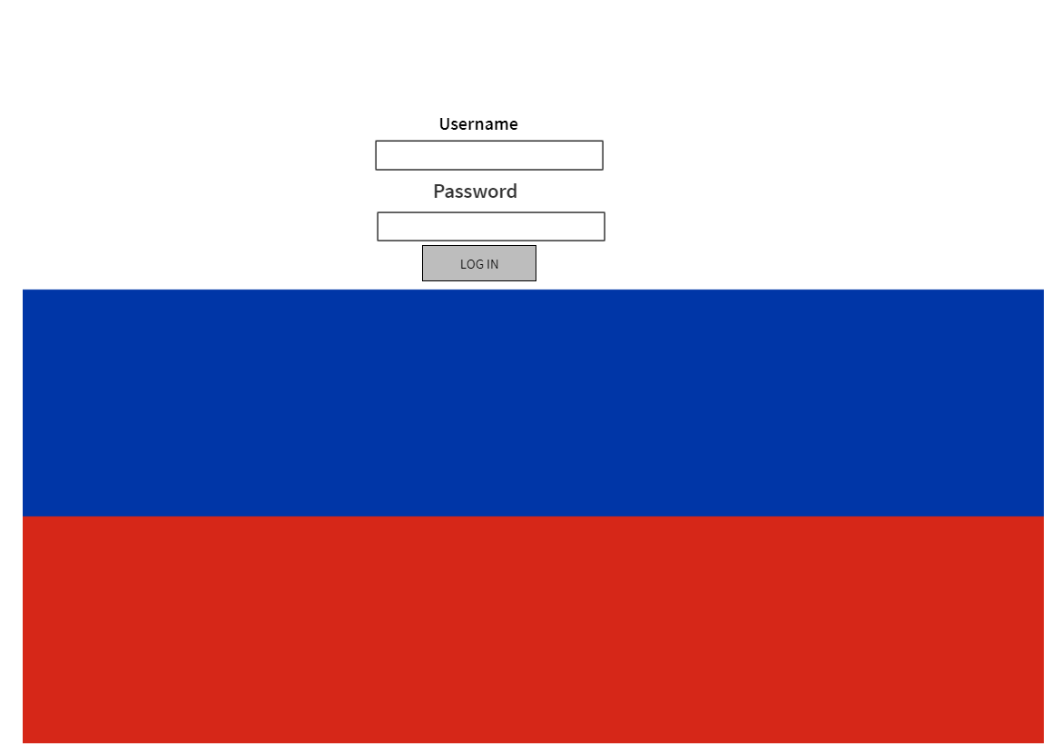**Mockup of Application Interface**

Group’s Leader Report

Assigned Duties and Git Accounts

|  |  |  |
| --- | --- | --- |
| Names | Duties | Git account |
| Ibrahim Mohamed | Documentation | Spartakhan |
| Shamaar Huntley | User interface | ShamaarHunt |
| Rudolph Adams | Testing | Akeem1 |
| Enrique Ward | Coding | PandemicSpark25 |
| Ayancey Barker | Refactoring | TuffyBarker |
| Arvinda Ramcharan | Storage Manager | arvinda2018 |
| Anthony Daly | System Analyst | AnthonyDalewall |

Group Leader Report

|  |  |  |
| --- | --- | --- |
| Name | USI | Grade |
| Shamaar Huntley | 1028970 | Excellent |
| Rudolph Adams | 1026689 | Excellent |
| Enrique Ward | 1026794 | Excellent |
| Ayancey Barker | 1025287 | Fair |
| Arvinda Ramcharan | 1021380 | Good |
| Anthony Daly | 1028513 | Good |